7TH GREEK SUMMER CAMP 2016 WITH

SHIHAN Tsutomou Wakiuchi 6DAN

SKIATHOS - GREECE

DATE: Wednesday 6th UNTIL SUNDAY 10th JULY

PLACE: ISLAND <SKIATHOS>

INFORMATION
PRICE FOR PARTICIPANTS:
In Single room 370 € per person
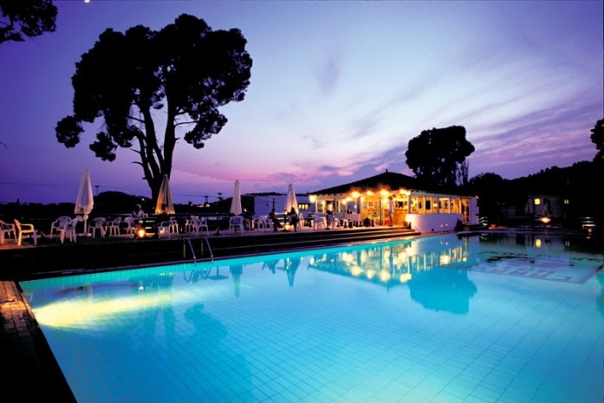
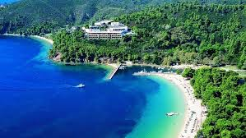
in double room 290€ per person (included: 4 days in Hotel Caravos on Skiathos Island, with breakfast, lunch and dinner (all buffet), cost seminar, Certificate with signature from Shihan Tsutomou Wakiuchi 6 Dan, memorial T-shirt of 7th Greek Summer Camp 2016, Sayonara Party and your transportation from Skiathos Island port or Skiathos Island air-port to the Official Hotel Caravos http://www.caravos.gr/)

(If someone would love to book earlier and stay more days before or after it costs 65€ per person with Breakfast, Lunch and Dinner all buffet) Please inform us, as soon as possible to book rooms (The official Hotel Caravos is located 200m away from famous Beach <Koukounaries> and Banana Beach and Agia Eleni) Also at the Official Hotel Caravos you can Rent a car and Diving Center where all customers can benefit from special rates that will apply to all participants of the event. It has a bus station with regular transportation that takes you arbitrarily to any part of the Skiathos Island)
(The age of Participants starts from 8 Years old)

(The Skiathos Island is one of the best Islands in Greece and it has a lot of tourism from May. Last Year (2015) the tourists who visited the Greek Islands were 22million and on Skiathos Island from 15th of July until the end of August all rooms were closed. Because of demand the prices of Hotel Rooms are so high and the price of 290€ p.p that we provide with all comfort for Skiathos data is considered as exceptional!

Due to high demand and not enough rooms to cover all participants, please book your participation by paying in advance 100 € until 31st of May!
BANK ACCOUNT: NATIONAL BANK 20291472841
NAME: IOANNIS STEFANOU
Check –in: Wednesday 6th of July from 12:00a.m
Check – out: Sunday 10th of July before 12:00

EXAMS: During the 7th Greek Summer Camp will give promotion exams from 1st – 3rd Dan. Examiners will be Shihan Tsutomu Wakiuchi 6 Dan and Shihan Ioannis Stefanou 5 Dan. For more informations I will send you e-mail soon.

Extra info:

- If a Branch Chiefs/ Dojo Operators books at least 6 athletes, he/she will be offered half price of the cost of participation.
- If a Branch Chiefs/ Dojo Operators books at least 10 athletes, he/she will be offered free of the cost of participation.
3. Any of the participants travel at the same date with us on the boat from Volos to Skiathos, will have a reduced ticket price for that journey - 30%.

- Due to the outmost beauty of Skiathos Island, our exceptional prices regarding the surroundings and conditions of the island, we urge you not to miss this opportunity combining training and tourism together, making friends, at our annual event, the 7th Greek Summer Camp.
- Sayonara Party will provide Greek Night (Syrtaki) and Greek Wines!

